Objective
This SOP defines the inspection procedure of PMA and prototype parts.
Note: Inspection of PMA and prototype parts by vendors is outside the scope of this document. They are required to follow “A-QS-100-01 Supplier Quality Requirements (SQR) PMA”.

Responsibilities
Quality Inspection is responsible to follow and maintain this procedure.

Definitions & Acronyms
Term | Meaning
ATP | Acceptance Test Plan
COTS | Commercial Off-The-Shelf
FAI | First Article Inspection
FAIR | First Article Inspection Report
NCR | Nonconformance Report
PMA | For purposes of this document, PMA are parts that the Company has FAA-PMA
PMA Inspector | An individual selected to perform First Article and entry into service inspections of PMA articles. The Quality Manager selects the PMA Inspector based on experience, training, and by demonstration of ability
PO | Purchase Order
Prototype | Of any mechanical device, a production model suitable for complete evaluation of mechanical and electrical form, design, and performance

Inspection Process
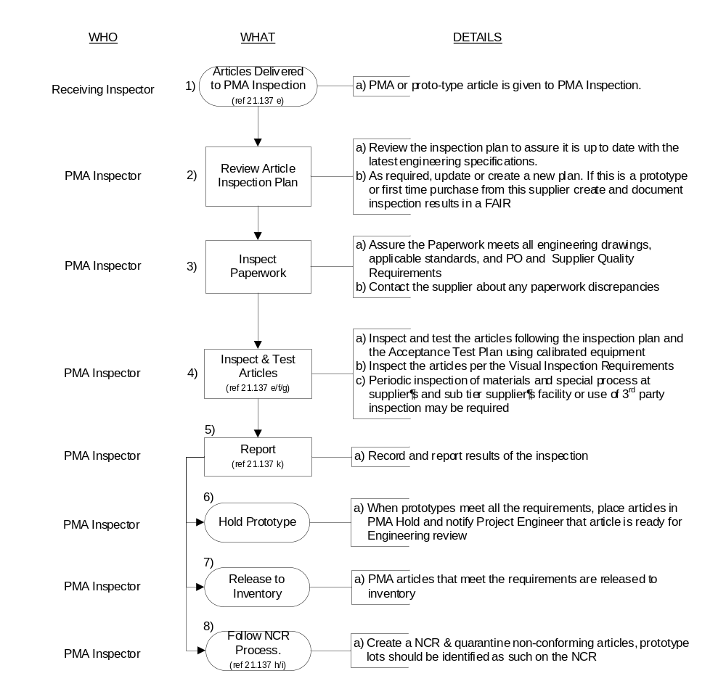

FAI (First Article Inspection)
Each Company part number is subject to first article inspection, independent of similar parts or multiple parts on a single drawing. A FAIR is to be completed by Inspection for any of the following conditions:
- The PO requires the vendor to provide a FAIR
- First time buy of any PMA Prototype parts or first time PMA Prototype parts made to a print revision
- First time part bought from the vendor (excluding COTS)
- When a FAIR is provided by the vendor due to a change
- More than 2 years since last received from the providing vendor (excluding COTS)
- When directed by Inspection Manager or Engineering

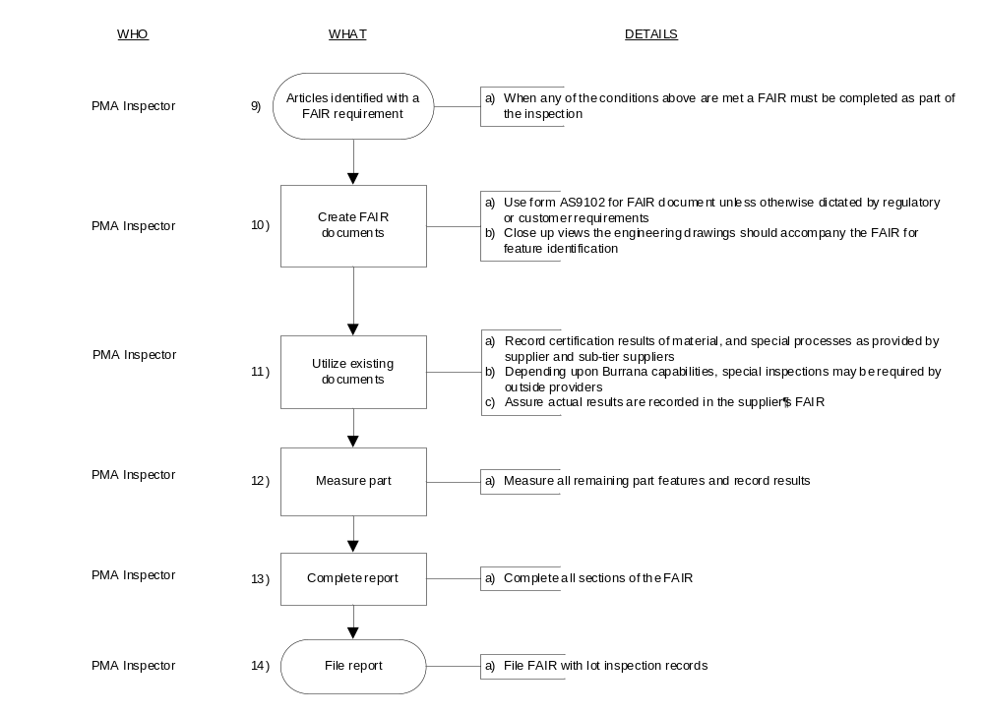
A FAIR is to include all details from sub-components of an assembly, or the sub-components are to have separate FAIRs with the exception of COTS items. The same applies to vendor protect part numbers to the final Burrana part number.

Inspection Damage
Parts damaged in inspection are to be removed from inventory and given to the Project Engineer for use in the engineering parts library or scrapped in accordance with the procedure.

Measurement Considerations
When Burrana does not have the ability to measure or verify all part features. For example - features only accessible before assembly, features that require specialty measurement equipment, parts that must remain in air-tight packaging, and destructive testing. In these cases, Burrana will use supplier certification for these features, request third party verification of these features, or analyze a sample part in a manner that renders the sample unusable.

Governing Documents
- 14 CFR 21.137(e) thru (k)
- AS9100
- AS9102

Forms and Documented Information

Document Control
FAIR - First Article Inspection Report (AS 9102). All approved FAIRs are to be stored electronically on the server.
Inspection results are filed in the uniPoint database, the ERP, dropbox, SharePoint, or hard copies.

